**National University of Computer & Emerging Sciences, Karachi**

**Computer Science Department**

**Spring 2022, Lab Manual – 08**

|  |  |
| --- | --- |
| **Course Code: CL-217** | **Course : Object Oriented Programming Lab** |
| **Instructor(s) :** | **Abeer Gauher, Hajra Ahmed, Shafique Rehman** |

**LAB - 8**

# Abstract Classes & Interface

**Abstract Class:**

A class which is declared as abstract is known as an **abstract class**. It can have abstract and non-abstract methods. It needs to be extended and its method implemented. It cannot be instantiated.

* An abstract class must be declared with an abstract keyword.
* It can have abstract and non-abstract methods.
* It cannot be instantiated.
* It can have constructors and static methods also.
* It can have final methods which will force the subclass not to change the body of the method.

**Syntax**

**abstract** **class** A{}

**Abstract Method:**

A method which is declared as abstract and does not have implementation is known as an **abstract method**.

**Syntax**

***abstract*** *void myFunction( ); //no method body and abstract*

**Example**

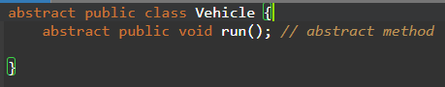

It is the responsibility of child class(es) to override the abstract function and “complete” the parent class.

**Example**

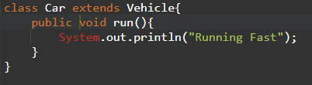

**Example: (***Using abstract class from main)*

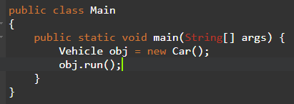

**Output:**

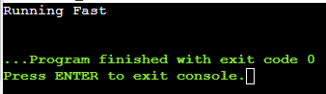

**Point to Remember:** We cannot create an instance of the abstract class.

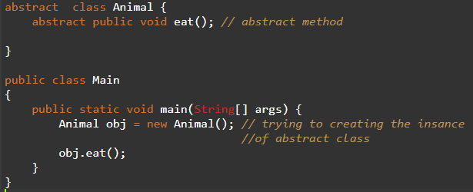

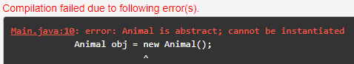

**Point to Remember:** An abstract class can contain concrete functions.

**Example:**

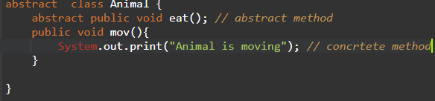

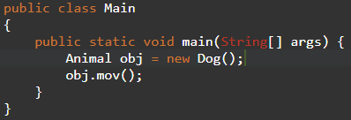

**Note: If there is an abstract method in a class, that class must be abstract.**

**Example:**

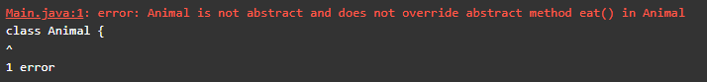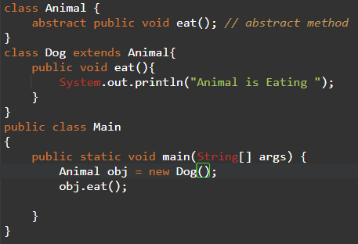

**Anonymous Class:**

If we do not have a child class, we can still override the abstract function by creating an **Anonymous Class.**

* A new class is defined (without a name, so called anonymous class)
* This new class extends abstract base class
* Abstract methods are overriden in this new class
* New instance of this new class is created and assigned to the parent variable

**Example**

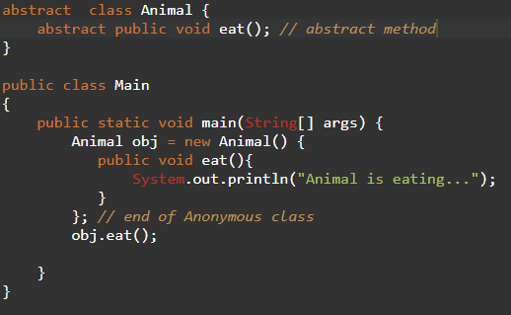

**Interfaces:**

An **interface** in Java is a blueprint of a class. It has static constants and abstract methods. A difference between abstract classes and interface is that there can be concrete methods in abstract classes whereas interface cannot contain any.

**How to create an interface:**

An interface is declared by using the interface keyword. It provides total abstraction; means all the methods in an interface are declared with the empty body, and all the fields are public, static and final by default. A class that implements an interface must implement all the methods declared in the interface.

**Syntax:**

***interface*** *<interface_name>{*

*// declare constant fields*

*// declare methods that are abstract*

*// by default.*

*}*

**Example:** *(Declaring an interface)*

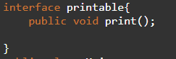

**Example:** *(Implementing interface in class)*

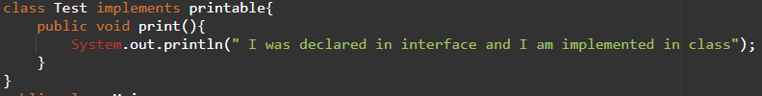

**Points to Remember:** We can create static methods in interfaces. But we must define their implementation inside the interface.

**Example:**

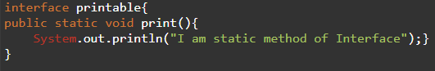  
**Points to Remember:** When a class implements an interface, we can save the object of that class in the interface variable.

**Example:**

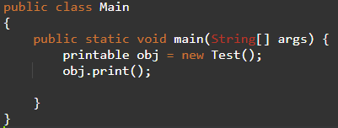

**Lab Exercise**

1. Create an abstract class 'Bank' with an abstract method 'getBalance'. $100, $150 and $200 are deposited in banks A, B and C respectively. 'BankA', 'BankB' and 'BankC' are subclasses of class 'Bank', each having a method named 'getBalance'. Call this method by creating an object of each of the three classes.
2. We have to calculate the percentage of marks obtained in three subjects (each out of 100) by student A and in four subjects (each out of 100) by student B. Create an abstract class 'Marks' with an abstract method 'getPercentage'. It is inherited by two other classes 'A' and 'B' each having a method with the same name which returns the percentage of the students. The constructor of student A takes the marks in three subjects as its parameters and the marks in four subjects as its parameters for student B. Create an object for eac of the two classes and print the percentage of marks for both the students.
3. Define an abstract class **Character** that contains:

* an integer health variable that represents the character's health,
* an integer attackPower variable that represents the character's attack power
* string name variable that represents the character's name.
* specialAbility() (abstract method): An abstract method that must be implemented by the subclass for each character type. This method defines the unique special ability of each character type.
* attack() (non-abstract method): A method that takes another Character object as a parameter and simulates an attack from the current character to the target character. It subtracts the attack power of the current character from the target character's health.
* defend() (non-abstract method): A method that simulates the current character defending itself.

Define **Warrior** class that contains:

* specialAbility() (method implementation): Overrides the abstract specialAbility() method in the Character class to define the unique special ability for a Warrior character. In this implementation, the warrior's attack power is doubled.

Define **Mage** class that contains:

* specialAbility() (method implementation): Overrides the abstract specialAbility() method in the Character class to define the unique special ability for a Mage character. In this implementation, the mage's attack power is increased by 20.

Define class **Archer** that contains:

* specialAbility() (method implementation): Overrides the abstract specialAbility() method in the Character class to define the unique special ability for an Archer character. In this implementation, the archer's attack power is increased by 15.

Finally, create an instance of each subclass in Game(Main Class) class and set their attributes such as name, health, and attackPower. Then call the attack() and defend() methods to simulate a battle between the characters. Also call the specialAbility() method to use the unique special ability of each character.

1. Create an abstract class 'Animals' with two abstract methods 'cats' and 'dogs'. Now create a class 'Cats' with a method 'cats' which prints "Cats meow" and a class 'Dogs' with a method 'dogs' which prints "Dogs bark", both inheriting the class 'Animals'. Now create an object for each of the subclasses and call their respective methods.
2. Define an interface called MessageService. The interface includes two methods:
   * send(String message, String recipient): This method takes two string values as parameters, representing the message content and the recipient's username. It sends the message to the recipient.
   * receive(): This method receives a message from the messaging service and returns it as a string value.

Create a WhatsApp class that implements interface and provides concrete implementations for methods in interface. In the Main class, create an instance of WhatsApp, and ask the user to enter the message he wants to send also enter the name to whom he wants to send a message and print it.

1. Define a interface called BankAccount. The interface includes three methods:

* deposit(double amount): This method takes a double value as a parameter and deposite amount in user account.
* withdraw(double amount): This method takes a double value as a parameter and with draw the amount from user accounts.
* getBalance(): This method returns the current balance of the user's account as a double value.

Create the SavingsAccount class implements interface and which have double private instance variable named balance and provides concrete implementations for methods of interface.

In the Main class, create an instance of SavingsAccount. Your program displays the menu to user. 1 for deposit, 2 for withdraw and 3 to get total balance. And 4 for exit the application.